**Epidemiological changes of scarlet fever** **before, during,** **and** **after** **the COVID-19** **pandemic in Chongqing, China: An 18-years surveillance and prediction study**

Rui Wu,2† Yu Xiong,2† Ju Wang,2 Baisong Li,2 Lin Yang,2 Han Zhao,2 Jule Yang,2 Tao Yin,2 Jun Sun,2 Li Qi,2 Jiang Long,2 Qin Li,2 Xiaoni Zhong,3 Wenge Tang,2* Yaokai Chen,1* and Kun Su1, 2, 3*

**Author affiliations**

1 Chongqing Public Health Medical Center, 109 Baoyu Road, Chongqing Municipality, China.

2 Chongqing Municipal Center for Disease Control and Prevention, Chongqing Municipal Key Laboratory for Highly Pathogenic Microbes, 8 Changjiang 2nd Road, Chongqing Municipality, China.

3 School of Public Health and Management, Chongqing Medical University, 1 Yixueyuan Road, Chongqing Municipality, China

† Rui Wu and Yu Xiong contributed equally to this work.

* Correspondence: [sukun325@163.com](mailto:sukun325@163.com), [yaokaichen@hotmail.com](mailto:yaokaichen@hotmail.com), and wengetangcq@163.com.

Full information about each author is available at the end of the article.

**Abstract**

**Background:** This study aimed to investigate the epidemiological changes in scarlet fever before and during the COVID-19 pandemic (2005–2022) and predict the incidence of the disease after the end of the dynamic zero-COVID-19 strategy in Chongqing Municipality, Southwest China.

**Methods:** Descriptive analysis was used to summarize the characteristics of the scarlet fever epidemic. Spatial autocorrelation analysis was utilized to explore the distribution pattern of the disease, and the autoregressive integrated moving average (ARIMA) model was constructed to predict its incidence in 2023 and 2024.

**Results:** Between 2005 and 2022, 9,109 scarlet fever cases were reported in Chongqing, which resulted in an annual average incidence of 1.634 per 100,000 people. Children aged 3–7 were the primary victims of this illness, with the highest average incidence found among children aged 6 (5.000 per 100,000 population). The incidence for the male was 1.51 times greater than that for the female. The monthly distribution of the incidence showed a bimodal pattern, with one peak occurring between April and June and another in November or December. The spatial autocorrelation analysis revealed that scarlet fever cases were markedly clustered; the areas with higher incidence were mainly concentrated in Chongqing’s urban areas and its adjacent districts. The incidence of scarlet fever increased by 106.54% and 39.33% in the post-upsurge period (2015–2019) and the dynamic zero-COVID-19 period (2020–2022), respectively, compared to the pre-upsurge stage (2005–2014) (p < 0.001). During the dynamic zero-COVID-19 period, reported cases decreased by 68.61%, 25.66%, and 10.59% (p < 0.001) in 2020, 2021, and 2022, respectively, compared to the predicted incidence. The incidence of scarlet fever is predicted to increase in 2023 (896 cases) and 2024 (882 cases).

**Conclusions:** In the past 18 years, the popular characteristics of scarlet fever have not changed much in Chongqing Municipality. However, the incidence of scarlet fever increased dramatically between 2015 and 2019 compared to the period from 2005 to 2014. After a short declined in 2020, it rebounded in 2021–2022. And it is predicted that the illness will grow rapidly in the coming two years and that the peak may exceed the level of cases seen before the COVID-19 pandemic. Therefore, the prevention and control of scarlet fever should be placed in a more prominent position in Chongqing Municipality and its surrounding areas.

**Keywords:** scarlet fever, COVID-19, ARIMA model, epidemiology

**Background**

Scarlet fever, caused by *Streptococcus pyogenes* (a group A streptococcus; GAS) used to be one of the most common acute respiratory seasonal infections, which mostly occurred in children under the age of 10 [1, 2]. The disease is mainly transmitted via air droplets (e.g., saliva or nasal discharge), close contact with the mucus or the skin of an infected patient, and fomites [3]. Its clinical features are high fever, headaches, sore throat, swollen lymph nodes, sandpaper-like red rash, and peeling and desquamation after the rash [4].

Scarlet fever used to be a common infectious disease among children, especially in Europe during the 18th and 19th centuries [1, 5]. The development of effective treatments (e.g., antibiotics) and the improvement of living standards (e.g., hygiene and nutrition) led to the disappearance of scarlet fever as a major cause of death in the worldwide pediatric population by the mid-20th century [6, 7]. However, in the 21st century, the illness has reemerged in some areas, as evidenced by outbreaks in several Asian countries, including Vietnam (2009) [1], mainland China and Hong Kong (2011) [8, 9], and South Korea (2015) [10]. The incidence of scarlet fever has shown a dramatic upward trend in some European countries, such as Poland (2013) [11], the United Kingdom (2014) [12], and Germany (2007–2016) [13].

In 1950, scarlet fever was classified as a category B notifiable infectious disease in China. In the early 1980s, it caused serious public-health problems and a considerable economic burden, after which the incidence gradually decreased [14]. Since the National Expanded Program of Immunization was launched in 2008, the incidence of vaccine-preventable infectious diseases among children in China has declined [15]. In contrast, cases of scarlet fever, for which there is no vaccine, have shown a substantial increase in the past 12 years in the country [16]. The annual average incidence went from 1.457 cases per 100,000 people in 2004 to 4.764 cases in 2011, peaking in 2015 at 5.0092 cases. The incidence remained high [17] until the outbreak of COVID-19 at the end of 2019 [18]. Several studies have found dramatic reductions in the incidence of multiple respiratory infections, such as scarlet fever, seasonal influenza, and mumps, after the beginning of the pandemic in China [19, 20].

Scarlet fever is one of the main respiratory infectious diseases in Chongqing Municipality. According to our surveillance, the incidence of the illness in the area also decreased sharply in 2020, and there have been many changes in its epidemiological characteristics. However, no studies have been conducted on these changes before and during the COVID-19 pandemic and on how the disease will evolve after COVID-19 pandemic in the municipality. Thus, we examined scarlet fever cases in Chongqing from 2005 to 2022 in order to analyze their epidemiological variations before and during the pandemic as well as to predict the incidence of the illness in the next two years, after the end of the dynamic zero-COVID-19 strategy.

**Methods**

**Study area**

Chongqing is located in Southwest China (north latitude 28°10'~32°13', east longitude 105°11'~110°11') and has a moist monsoon climate typical of semitropical zones. It is one of the regional economic centers and the largest province-level municipality under direct control of the national government (82,402.95 square kilometers). It is composed of 26 districts, eight counties, and four autonomous counties. At the end of 2022, the permanent resident population amounted to 32.124 million people.

**Case definitions and data sources**

In response to the severe acute respiratory syndrome outbreak of 2003, the Chinese government established a real-time National Notifiable Infectious Disease Surveillance System (NNIDSS) for 40 infectious illnesses. Based on their severity, these illnesses are divided into three categories (A, B, and C), which must be reported according to a specified time frame. Scarlet fever is classified as a category B notifiable infectious disease, and all probable, clinically diagnosed, and laboratory-confirmed cases must be reported to the NNIDSS within 24 hours of detection. The centers for disease control and prevention supervise and inspect the reporting of infectious diseases every year to ensure that every diagnosed infectious disease including scarlet fever is reported. All these cases should comply with the diagnosis of WS 282-2008 and GB 15993-1995 issued by the Health Ministry of China.

In this observational study, the data on scarlet fever cases was extracted from the NNIDSS. The data included age, sex, address, and number of cases, and it covered the period from January 1, 2005, to December 31, 2022. The resident population data for Chongqing from 2005 to 2022 was downloaded from the official website of the *Chongqing Statistical Yearbook*. The birth rate data was sourced from China’s official *Statistical Yearbook*. “Prenursery children” are children aged 0–2 who are taken care of by family members and/or a nanny at home. “Kindergarten” is a form of education for children aged 3–6. “Students” refers to individuals aged over 7 who are studying (from primary school to college).

**Statistical analysis**

The incidence of scarlet fever (per 100,000 people) was defined as the number of cases per year divided by the population size. A two-proportion Z-test was used to evaluate whether the annual incidence change was statistically significant. ArcGIS 10.8 (ArcMap, ESRI Inc., Redlands, CA, USA) was employed to create a spatial model that visualized and compared the average incidence in each district/county per year. Spatial autocorrelation analysis was utilized to explore whether there was a correlation in the study region from a global perspective and to describe the spatial graph of the attribute values in said region [21]. The significance level of all these analyses was set at 0.05 in two-tailed tests. Based on morbidity data from 2005 to 2019, the autoregressive integrated moving average (ARIMA) model was used to predict the incidence of scarlet fever in 2020–2022, assuming no COVID-19 was present. The ARIMA model can be generally expressed as ARIMA (p, d, q) × (P, D, Q) [n]. The parameters p, d, and q represent the orders of the nonseasonal autoregression, difference, and moving average, respectively; P, D, and Q are the corresponding seasonal autoregression, difference, and moving average orders. Finally, n is the seasonal period of the sequence (in this study, 12 months).

R 4.0 (Vienna, Austria), GraphPad Prism 9 (San Diego, CA, USA), and Excel 2021 were used for the statistical analyses. The ARIMA model was constructed by using the “arima” function in the stats package of R.

**Results**

**Incidence in different periods**

From January 1, 2005, to December 31, 2022, a total of 9,109 scarlet fever sporadic cases were reported in Chongqing, which resulted in an annual average incidence of 1.634 per 100,000 people. According to the different incidence levels in the municipality, the past 18 years (2005–2022) were divided into three phases: 2005–2014 (pre-upsurge period), 2015–2019 (post-upsurge period), and 2020–2022 (dynamic zero-COVID-19 period). The average incidence remained relatively stable and low in 2005–2010, with a slight increase after 2011 (1.634 per 100,000 people). The first upsurge in cases occurred in 2015, with a significantly higher incidence of 3.121 per 100,000 people; this rise continued and peaked in 2019 (3.018 per 100,000 people). This trend changed completely when the incidence dropped sharply in 2020 (0.854 per 100,000 people), while the situation was reversed in 2021–2022 (Figure 1A).

There was a bimodal seasonal pattern in the monthly incidence. The first peak usually occurred in late spring, mainly between April and June, about two or three months after the spring semester had begun, with the highest monthly incidence (5.083 per 100,000) recorded in June. The second peak typically happened in November or December, about two or three months after the autumn semester had begun. The first peak was much higher than the second. Every year, the monthly incidences reached the two lowest levels during the school holidays in spring and summer (Figure 1B). The incidence increased by 106.54% in the post-upsurge period (2015–2019) and by 39.33% during the dynamic zero-COVID-19 period (2020–2022), compared to that in the pre-upsurge period (2005–2014) (p < 0.001). The incidence decreased by 165.84% (2020), 67.22% (2021), and 12.19% (2022), compared to the average incidence during the post-upsurge period (2015–2019) (see Additional File 1).

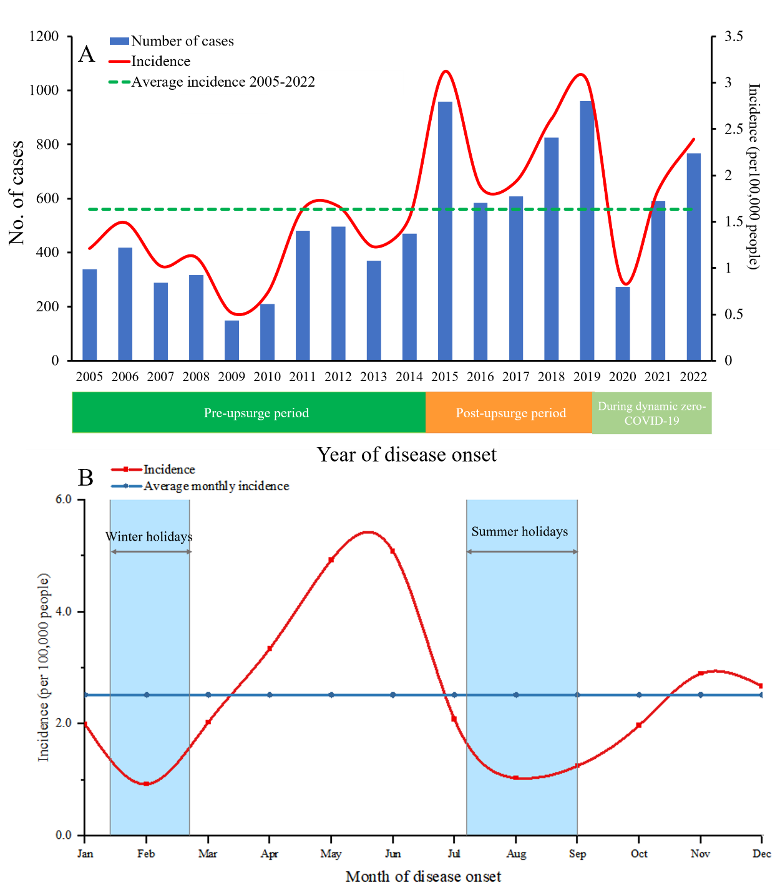

**Figure 1A.** Annual incidence of scarlet fever in Chongqing, 2005–2022.

**Figure 1B.** Monthly incidence of scarlet fever (12-month period) in Chongqing.

Notes: The blue areas indicate the school holidays in spring and summer.

**Epidemiological characteristics**

Of the 9,109 cases, 5,481 were male and 3,628 were female, with a sex ratio of 1.5:1. Scarlet fever cases were detected in all age groups. The median age at onset of disease was 5 years (ranging from 3 days to 78 years). Children aged 6 had the highest average annual incidence (5.0002 per 100,000 people) and those aged 60 or older had the lowest average annual incidence (0.0100 per 100,000 population). Most cases were from the age group 3–7 years (67.36%), followed by 8–12 years (18.20%), 0–2 years (9.86%), 13–17 years (2.70%), and more than 18 years (1.88%). Kindergarten children were the dominant infected population, accounting for as much as 49.95% of cases, followed by students (34.05%), and prenursery children (9.86%).

In the total population, the annual incidence was persistently higher among males than females (Figure 2A). The annual incidences peaked in different years among different age groups. The annual incidence of patients aged 0–2 years fluctuated relatively steadily, and the number of females exceeded that of males, with the peak being reached in 2018. The annual incidence of reported cases peaked among those aged 3–6 in 2015, 2018, 2019, and 2022. Among those aged 7–14, the peaks were reached in 2015, 2019, and 2022. In contrast, the annual incidence of the age group over 14 years remained substantially lower than that of the other age groups (Figure 2B).

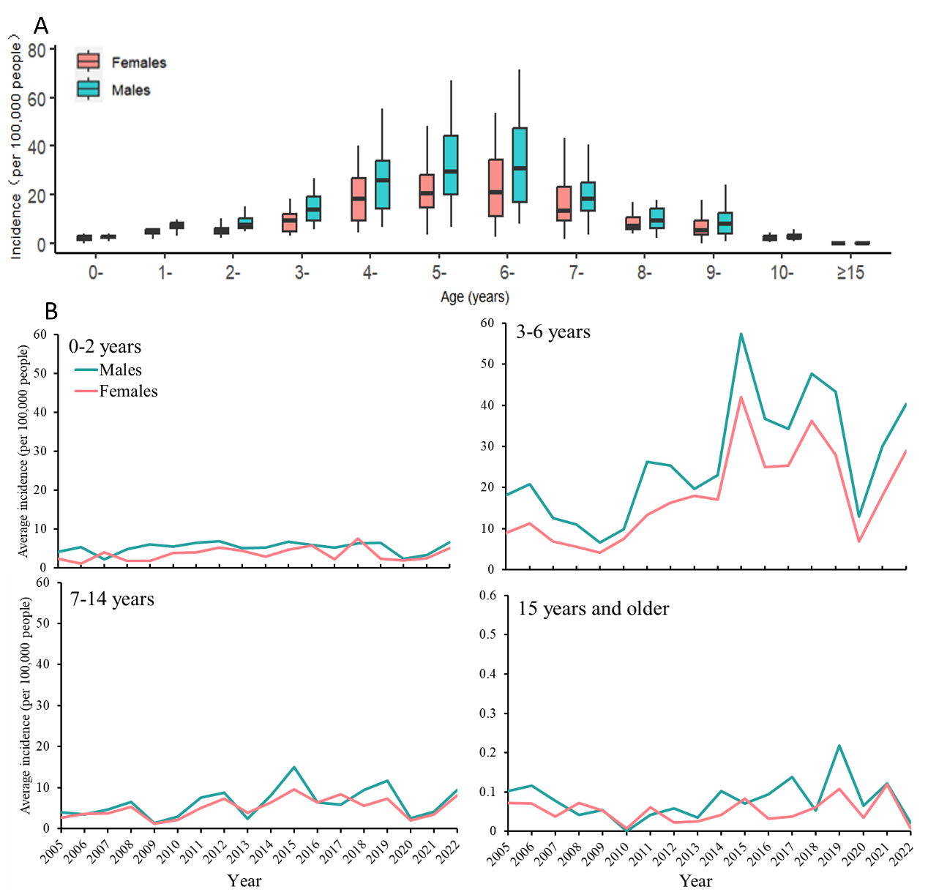

**Figure 2A.** Sex-specific distribution of reported scarlet fever cases by age in Chongqing, 2005–2022. **Figure 2B.** Average incidence by age group and sex in Chongqing, 2005–2022.

**Spatial distribution**

The spatial distribution of scarlet fever cases revealed that there were differences in the incidence in different regions during the three periods. The areas with higher incidence were mainly Chongqing’s urban zone and its nearby districts from 2005 to 2014 (Figure 3A). In 2015–2019, although the incidence was still higher in the urban zone and the surrounding areas, the northeastern and southeastern parts of Chongqing became two highly endemic regions; one mainly covered Wanzhou and Liangping Districts, while the other Qianjiang District (Figure 3B). Since 2020, scarlet fever has spread to more remote regions in eastern and northwestern Chongqing (Figure 3C).

The results of the spatial autocorrelation analysis indicated that there was an evident spatial correlation blinding the cases of scarlet fever diseases. The differences between the pre-upsurge period (2005–2014) and the post-upsurge period (2015–2019) were statistically significant (p < 0.05), which revealed that the incidence had a significant positive spatial correlation at the county scale in the two stages in Chongqing and that the distribution of the cases was not random. The map for 2005–2014 showed that high-high cluster regions were mainly concentrated in Chongqing’s urban zone and the adjacent Bishan District (Figure 3D); the incidence was also high in the surrounding regions. During the 2015–2019 period, in addition to the high-high and low-high clusters in the urban zone, a high-low cluster appeared more or less in Qianjiang District, southeast of Chongqing, which indicates that the incidence there was also relatively high. While the situation in the low-low areas was similar to that in 2005–2014, there were clusters in the Northeast (Figure 3E). Since 2020, there has only been a low-high clustering in Hechuan District, which shows that spatiotemporal incidence clusters of the disease were not apparent in Chongqing at this stage (Figure 3F).

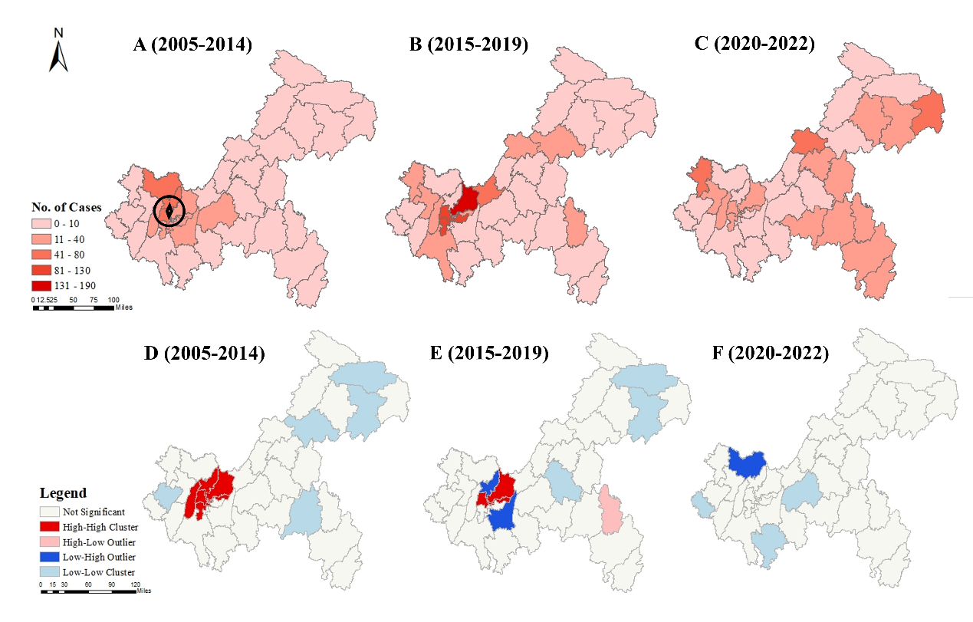

**Figures 3A–3C.** Spatiotemporal distribution of annual averages of scarlet fever cases in Chongqing, 2005–2022. The map was created with ArcGIS 10.8 software based on the public geographic data downloaded from the Science and Data Center for Resources and the Environment, Institute of Geographic Sciences and Natural Resources Research, CAS (https://www.resdc.cn/). The marked location in Figure 4A is the urban zone of Chongqing.

**Figures 3D–3F.** Results of the local spatial autocorrelation analysis of scarlet fever cases in Chongqing, 2005–2022. The map was created with ArcGIS 10.8 software. There are four kinds of results, and the same color describes the same kind of cluster. Red represents hot spots, which means that the surrounding area and the study areas have a high incidence of the disease. Blue signals cold spots. The blank parts were the scanning areas with no statistical significance.

**Prediction of future incidence**

Considering that there were obvious periodic characteristics, a one-step nonseasonal difference and a one-step seasonal difference with a period of 12 seasonal differences were performed to eliminate the trends and seasonal effects, respectively. The ACF and PACF plots had tail characteristics, given that the values of p, q, P, and Q do not generally exceed 2; hence, trial orders from 0 to 2 were performed. Based on the results of the goodness-of-fit test statistics, we confirmed the optimal ARIMA (1,0,0) (2,1,2) [12] model, with the lowest AIC being the best. Finally, the results of the Box-Ljung tests for the model showed that the residual sequence was a white noise sequence. The monthly cases of scarlet fever for the period 2005–2019 were chosen as the training set. Based on the optimal ARIMA model, the incidence of scarlet fever would have been much higher in 2020–2022 if there had been no COVID-19 pandemic. The reported annual incidence of the illness decreased by 68.61%, 25.66%, and 10.59% in 2020, 2021, and 2022 (p < 0.001, see Additional File 3), respectively, compared to the predicted value (Figure 4).

By using the actual number of scarlet fever cases in the period 2015–2019 and the predicted number for 2020–2022, the optimal ARIMA (4,1,4) (0,1,1) [12] model was built to predict the number of cases per month over the next two years. The final model found that there should be 896 and 882 cases in 2023 and 2024, respectively. The two monthly peaks in both years should be in May (143 cases, 141 cases) and November (88 cases, 87 cases) (Figure 4).

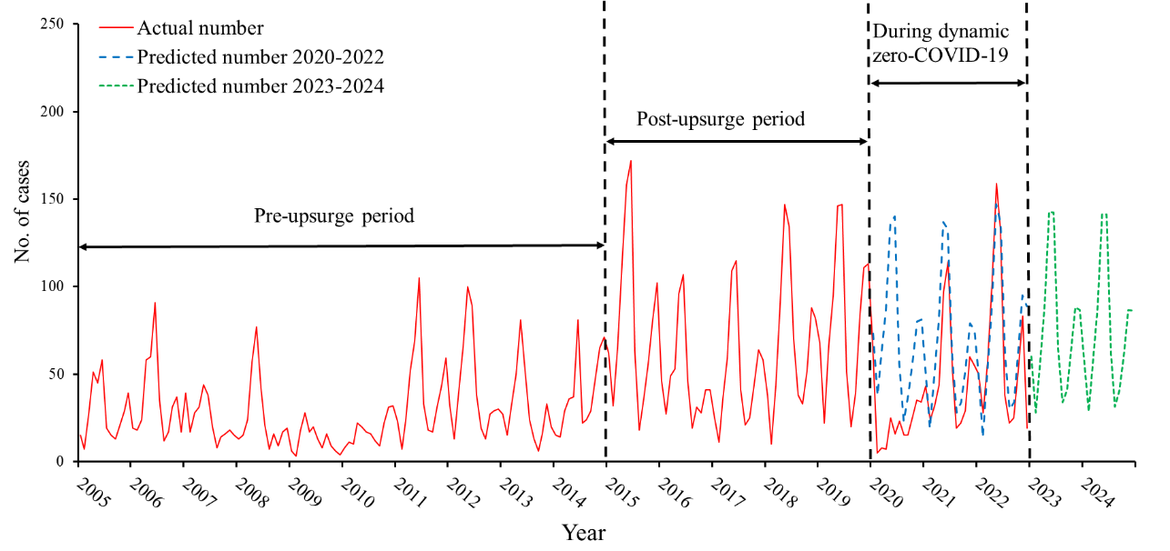

**Figure 4.** Prediction diagram of the monthly scarlet fever cases in the study period.

**Discussion**

Using an 18-year surveillance dataset of scarlet fever, we characterized patterns of disease incidence over the years in Chongqing, a municipality located in Southwest China. Chongqing experienced a rise in scarlet fever cases from 2015, which peaked in 2019 before suddenly decreasing in 2020; the trend rebounded in 2021–2022. This study analyzed changes in spatial and seasonal patterns as well as age- and sex-specific incidence. Finally, it predicted the incidence of the disease in Chongqing for 2023 and 2024.

In China, the incidence of scarlet fever fluctuated upward between 2005 and 2019, especially after 2011; this is consistent with findings from other countries, including Singapore [22], Vietnam [1], South Korea [10], Poland [11], Germany [13], and the United Kingdom [12]. One important reason for the 2011 outbreak in China was the natural cyclical pattern of scarlet fever, which occurs approximately every six years [23]. The second reason was the higher number of susceptible children due to the partial two-child policy, which came into effect in 2011 [24]. In the past 18 years, the epidemic of scarlet fever in Chongqing can be divided into three stages: 2005–2014 (pre-upsurge period), 2015–2019 (post-upsurge period), and 2020–2022 (dynamic zero-COVID-19 period). This evolution was similar, but not identical, to the trend throughout China [26] and other regions. In contrast to the more than 10-fold increase in Chinese Hong Kong, the upward trend of scarlet fever in Chongqing was less pronounced over the same period in 2011 [25]. The rapid rise in Chongqing seemed to begin in 2015 and peak in 2019 [26]. Notably, in China, the annual incidence among patients aged 3–6 peaked in 2015 (5.0092 per 100,000 people) [17], which is consistent with Chongqing as well as other regions of the country, such as Jiangsu [26], Guangzhou [2], and Hong Kong [9]. Furthermore, we found that the highest incidence of the illness in Chongqing (3.121 per 100,000 people) was much lower than that in Beijing (14.25 per 100,000) during the 2005–2014 period [27]. It was also lower than the incidence in Shenyang (31.24 per 100,000) in 2018 [3] and in Chinese Hong Kong (18.1 per 100,000) in 2012–2015 [25]. Finally, it was lower than that in South Korea (13.7 per 100,000) in 2015 [10]. During this period, the birth rate in Chongqing was lower than the national average, which resulted in a relatively low number of susceptible children [28]. The 2015 upsurge may have been affected by an increase in the number of cases nationwide and a higher risk of population exposure.

Remarkably, scarlet fever had a pattern with two annual seasonal peaks in Chongqing. The first peak was in April–June and the second one in November–December. In 2020, this pattern was broken by the measures to prevent and control the spread of COVID-19. Schools either suspended classes or offered them online, and even when schools reopened in 2020 in Chongqing, students were required to comply with strict public-health rules [29]. In 2021–2022, as the severity of the epidemic gradually lessened, COVID-19-related prevention and control policies were relaxed, and face-to-face teaching resumed. Although the impact of public-health measures on the incidence of scarlet fever in 2021 was still significant, it was milder than in 2020; hence, the number of cases started rising again. In summary, several factors contributed to the unprecedented decrease in the incidence of the illness. First, school closures reduced the spread of scarlet fever among children and adolescents, because schools are transmission hotspots for respiratory infectious diseases. Second, the implementation of public-health interventions (especially controlling the movement of people when feasible and appropriate) and the strengthening of hygienic behaviors and risk prevention awareness could have partially reduced the transmission of bacterial illnesses, including scarlet fever. This might have made it more difficult for susceptible populations to be exposed to pathogens [30]. This evidence confirms that early vigilance and more stringent public-health policies can interrupt the transmission dynamics of scarlet fever [31]. Third, the total number of cases registered by the Infectious Diseases Department might have been underestimated during the emergency response stage. Fear of COVID-19 infection and the closure of community management centers caused inconvenience to some patients; therefore, those with mild symptoms might have sought less or no hospital treatment during the pandemic.

Our study found that children aged 3–7 were the group most affected by scarlet fever in Chongqing. This finding is consistent with evidence from other countries and regions, such as the United Kingdom [12], Hong Kong [25], Shenyang [3], and Jiangsu [26]. This result could be partly attributable to the group’s scarce immunity and the high risk of a concentrated population in kindergartens and primary schools, which might promote the spread of bacterial diseases [23]. We also found that males were more prone to be infected in all age groups. This could be attributable to more physical activities or poorer personal hygiene among men compared to women, which increases the chances of exposure to bacteria. If we combine this finding with the previous one indicating that the incidence of scarlet fever was clearly related to the clustering of the population [32], we may suggest that school-based measures should be adopted for boys in Chongqing’s kindergartens and primary schools.

Based on the spatial autocorrelation analysis of the whole population, spatial autocorrelation was more easily detected in the areas with higher incidence. Hotspots were found in Chongqing’s urban zone and its surrounding areas, which indicates that these locales should be paid special attention. The main reason for this result is that the urban zone is a hub of transportation and communication; it is also where Chongqing’s best medical and educational resources are found. The area has a high population density and large numbers of susceptible people. Thus, the urban zone and its surroundings should become the key focus for Chongqing’s government authorities in their attempts to prevent and control scarlet fever, especially after the relaxation of anti‐COVID-19 measures. Notably, some spatiotemporal incidence clusters were detected, such as Qianjiang District in the Southeast during 2015–2019 and Hechuan District in the Northeast during 2020–2022. As the various districts and counties continue to develop their economies, transportation networks, and health-care systems, the incidence of scarlet fever has changed, gradually spreading from the urban zone to the suburban areas. Therefore, local public-health departments should strengthen scarlet fever surveillance and prevention and promote appropriate behaviors among high-risk groups and during the peak periods in the newly endemic areas.

With the implementation of category B management for COVID-19, stricter non-pharmaceutical interventions, such as wearing masks indoors, travel restrictions, and school closures, have been eliminated. We predict that the incidence of scarlet fever in Chongqing will rise considerably in the next two years; it may even exceed the level seen before the COVID-19 pandemic. Therefore, the disease might still be a major public-health problem in Chongqing. Scientific and reasonable epidemic-prevention measures could not only reduce the incidence of infectious diseases and protect public health but also promote the recovery and development of the economy to a certain extent [33]. In the future, public-health interventions, such as early vigilance, strengthening the monitoring of key high-risk groups and high-risk areas, and enhancing public-health awareness, could prove effective in preventing and controlling the spread of scarlet fever.

**Conclusion**

In the past 18 years, the popular characteristics of scarlet fever have not changed much in Chongqing Municipality. However, the incidence of scarlet fever increased dramatically between 2015 and 2019 compared to the period from 2005 to 2014. After a short declined in 2020, it rebounded in 2021–2022. And it is predicted that the illness will grow rapidly in the coming two years and that the peak may exceed the level of cases seen before the COVID-19 pandemic. Therefore, the prevention and control of scarlet fever should be placed in a more prominent position in Chongqing Municipality and its surrounding areas. The government take measures to protect children aged 3–7, especially boys, during the school period. More resources should be invested in districts and counties where the epidemic is more serious.

**Abbreviations**

COVID-19: the coronavirus that causes a severe acute respiratory syndrome, discovered in 2019. NNIDSS: National Notifiable Infectious Disease Surveillance System. ARIMA model: autoregressive integrated moving average model.

**Acknowledgments**

The authors would like to express their gratitude for the disease data provided by the medical institutions and the Centers for Disease Control and Prevention of every district and county in Chongqing.

**Authors’ contributions**

KS and YKC supervised the study. WGT and XNZ designed the study. TTL and QL collected and organized the data. TY and JS analyzed the data. LQ and JL interpreted the results. RW wrote the first draft. YX and JW reviewed and edited this manuscript. All the authors contributed to the final draft and approved the submitted version.

**Funding**

This research was supported by the Key Research and Development Project in theHealth Field of Chongqing (no. CSTC2021jscx-gksb-N0003), Medical Scientific Research Project of Chongqing (no. 2022WSJK030) and Scientific Research Project of Chongqing Talent Plan (no. cstc2022ycjh-bgzxm0251).

**Availability of data and materials**

The data that supports the findings of this study is available from the Chongqing CDC, but restrictions apply to its availability. The data was used under license for the current study, and it is not publicly available. However, the data is available from the authors upon reasonable request and with the permission of the Chongqing Center for Disease Control and Prevention. If anyone want to cooperate with Chongqing CDC and get data, please contact Chongqing CDC staff (E-mail: [sukun325@163.com](mailto:sukun325@163.com)).

**Ethics approval and consent to participate**

Not applicable. The Research Ethics Committee of the Chongqing Center for Disease Control and Prevention declared that this study did not require ethics approval.

**Consent for publication**

Not applicable.

**Competing interests**

We declare no competing interests.

**Author details**

1 Chongqing Public Health Medical Center, Chongqing 400036, China. 2 Chongqing Municipal Center for Disease Control and Prevention, Chongqing Municipal Key Laboratory for High Pathogenic Microbes, Chongqing 400042, China. 3 School of Public Health and Management, Chongqing Medical University, Chongqing 400016, China.

**Additional information**

**Additional File 1.** Changes in the average yearly incidences (per 100,000) of scarlet fever during the three stages in Chongqing.

|  |  |  |  |  |  |  |  |  |  |  |  |  |
| --- | --- | --- | --- | --- | --- | --- | --- | --- | --- | --- | --- | --- |
| Disease | Pre-upsurge period vs. post-upsurge period | | | | Post-upsurge period vs. dynamic zero-COVID-19 period | | | | Pre-upsurge period vs. dynamic zero-COVID-19 period | | | |
|  | 2005–2014 | 2015–2019 | Change (%) | P value | 2015–2019 | 2020–2022 | Change (%) | P value | 2005–2014 | 2020–2022 | Change (%) | P value |
| Scarlet fever | 1.2163 | 2.5122 | 106.54 | < 0.001 | 2.5122 | 1.6947 | -32.54 | < 0.001 | 1.2163 | 1.6947 | 39.33 | < 0.001 |

Notes: changes = (x1 − x2)/x2 × 100%; x1, x2: average yearly incidences during the three stages; the p value was computed through a two-proportion Z-test.

**Additional File 2.** Moran’s I of the global spatial autocorrelation analysis for scarlet fever in Chongqing during the study period

|  |  |  |  |
| --- | --- | --- | --- |
| Period | Moran’s I | Z-score | P value |
| Pre-upsurge period | 0.4858 | 4.9566 | 0.0001* |
| Post-upsurge period | 0.2410 | 0.0094 | 0.0056* |
| Dynamic zero-COVID-19 period | -0.0011 | 0.2562 | 0.7978 |

Notes: * indicates that the p value is statistically significant.

**Additional File 3.** Changes in the yearly incidences (per 100,000) of scarlet fever between the observed and predicted values from 2020 to 2022.

|  |  |  |  |
| --- | --- | --- | --- |
| Year | 2020 | 2021 | 2022 |
| Actual incidence | 0.8538 | 1.8400 | 2.3903 |
| Predicted incidence | 2.7205 | 2.4751 | 2.6735 |
| Changes (%) | -68.61 | -25.66 | -10.59 |
| P value | < 0.001 | < 0.001 | < 0.001 |

Notes: changes = (x1 − x2)/x2 × 100%; x1: average yearly incidence (actual), x2: average yearly incidence (predicted); the p value was computed through a two-proportion Z-test.

**References**

1. Andrey DO, Posfay-Barbe KM. Re-emergence of scarlet fever: old players return? Expert Rev Anti Infect Ther. 2016;14(8):687-9. <https://doi.org/10.1080/14787210.2016.1195684>.

2. Lu JY, Chen ZQ, Liu YH, Liu WH, Ma Y, Li TG, et al. Effect of meteorological factors on scarlet fever incidence in Guangzhou City, Southern China, 2006-2017. Sci Total Environ. 2019;663:227-35. <https://doi.org/10.1016/j.scitotenv.2019.01.318>.

3. Chen H, Chen Y, Sun B, Wen L, An X. Epidemiological study of scarlet fever in Shenyang, China. BMC Infect Dis. 2019;19(1):1074. <https://doi.org/10.1186/s12879-019-4705-9>.

4. Walker MJ, Barnett TC, McArthur JD, Cole JN, Gillen CM, Henningham A, et al. Disease manifestations and pathogenic mechanisms of Group A Streptococcus. Clin Microbiol Rev. 2014;27(2):264-301. <https://doi.org/10.1128/CMR.00101-13>.

5. Gale AH. A century of changes in the mortality and incidence of the principal infections of childhood. Arch Dis Child. 1945;20(101):2-21. <https://doi.org/10.1136/adc.20.101.2>.

6. Duncan SR, Scott S, Duncan CJ. Modelling the dynamics of scarlet fever epidemics in the 19th century. Eur J Epidemiol. 2000;16(7):619-26. <https://doi.org/10.1023/a:1007645110006>.

7. Quinn RW. Comprehensive review of morbidity and mortality trends for rheumatic fever, streptococcal disease, and scarlet fever: the decline of rheumatic fever. Rev Infect Dis. 1989;11(6):928-53. <https://doi.org/10.1093/clinids/11.6.928>.

8. Duan Y, Yang LJ, Zhang YJ, Huang XL, Pan GX, Wang J. Effects of meteorological factors on incidence of scarlet fever during different periods in different districts of China. Sci Total Environ. 2017;581-582:19-24. <https://doi.org/10.1016/j.scitotenv.2017.01.010>.

9. Lau EH, Nishiura H, Cowling BJ, Ip DK, Wu JT. Scarlet fever outbreak, Hong Kong, 2011. Emerg Infect Dis. 2012;18(10):1700-2. <https://doi.org/10.3201/eid1810.120062>.

10. Park DW, Kim SH, Park JW, Kim MJ, Cho SJ, Park HJ, et al. Incidence and Characteristics of Scarlet Fever, South Korea, 2008-2015. Emerg Infect Dis. 2017;23(4):658-61. <https://doi.org/10.3201/eid2304.160773>.

11. Czarkowski MP, Staszewska E, Kondej B. Scarlet fever in Poland in 2013. Przegl Epidemiol. 2015;69(2):223-7, 349-52. <https://www.ncbi.nlm.nih.gov/pubmed/26233076>.

12. Lamagni T, Guy R, Chand M, Henderson KL, Chalker V, Lewis J, et al. Resurgence of scarlet fever in England, 2014-16: a population-based surveillance study. Lancet Infect Dis. 2018;18(2):180-7. <https://doi.org/10.1016/S1473-3099(17)30693-X>.

13. Brockmann SO, Eichner L, Eichner M. Constantly high incidence of scarlet fever in Germany. Lancet Infect Dis. 2018;18(5):499-500. <https://doi.org/10.1016/S1473-3099(18)30210-X>.

14. You Y, Qin Y, Walker MJ, Feng L, Zhang J. Increased Incidence of Scarlet Fever - China, 1999-2018. China CDC Wkly. 2019;1(5):63-6. <https://www.ncbi.nlm.nih.gov/pubmed/34594606>.

15. Yang S, Wu J, Ding C, Cui Y, Zhou Y, Li Y, et al. Epidemiological features of and changes in incidence of infectious diseases in China in the first decade after the SARS outbreak: an observational trend study. Lancet Infect Dis. 2017;17(7):716-25. <https://doi.org/10.1016/S1473-3099(17)30227-X>.

16. Mahara G, Chhetri JK, Guo X. Increasing prevalence of scarlet fever in China. BMJ. 2016;353:i2689. <https://doi.org/10.1136/bmj.i2689>.

17. Liu Y, Chan TC, Yap LW, Luo Y, Xu W, Qin S, et al. Resurgence of scarlet fever in China: a 13-year population-based surveillance study. Lancet Infect Dis. 2018;18(8):903-12. <https://doi.org/10.1016/S1473-3099(18)30231-7>.

18. Wu J, Li J, Zhu G, Zhang Y, Bi Z, Yu Y, et al. Clinical Features of Maintenance Hemodialysis Patients with 2019 Novel Coronavirus-Infected Pneumonia in Wuhan, China. Clin J Am Soc Nephrol. 2020;15(8):1139-45. <https://doi.org/10.2215/CJN.04160320>.

19. Yamamoto-Kataoka S, Kataoka Y, Tochitani K, Miyakoshi C, Yamamoto Y. Influence of anti-coronavirus disease 2019 policies on 10 pediatric infectious diseases. Pediatr Int. 2022;64(1):e14958. <https://doi.org/10.1111/ped.14958>.

20. Xiao J, Dai J, Hu J, Liu T, Gong D, Li X, et al. Co-benefits of nonpharmaceutical intervention against COVID-19 on infectious diseases in China: A large population-based observational study. Lancet Reg Health West Pac. 2021;17:100282. <https://doi.org/10.1016/j.lanwpc.2021.100282>.

21. Wang C, Li X, Zhang Y, Xu Q, Huang F, Cao K, et al. Spatiotemporal Cluster Patterns of Hand, Foot, and Mouth Disease at the County Level in Mainland China, 2008-2012. PLoS One. 2016;11(1):e0147532. <https://doi.org/10.1371/journal.pone.0147532>.

22. Yung CF, Thoon KC. A 12 year outbreak of scarlet fever in Singapore. Lancet Infect Dis. 2018;18(9):942. <https://doi.org/10.1016/S1473-3099(18)30464-X>.

23. You Y, Davies MR, Protani M, McIntyre L, Walker MJ, Zhang J. Scarlet Fever Epidemic in China Caused by Streptococcus pyogenes Serotype M12: Epidemiologic and Molecular Analysis. EBioMedicine. 2018;28:128-35. <https://doi.org/10.1016/j.ebiom.2018.01.010>.

24. Ouyang Y. China relaxes its one-child policy. Lancet. 2013;382(9907):e28. <https://doi.org/10.1016/s0140-6736(13)62544-1>.

25. Lee CF, Cowling BJ, Lau EHY. Epidemiology of Reemerging Scarlet Fever, Hong Kong, 2005-2015. Emerg Infect Dis. 2017;23(10):1707-10. <https://doi.org/10.3201/eid2310.161456>.

26. Zhang Q, Liu W, Ma W, Shi Y, Wu Y, Li Y, et al. Spatiotemporal epidemiology of scarlet fever in Jiangsu Province, China, 2005-2015. BMC Infect Dis. 2017;17(1):596. <https://doi.org/10.1186/s12879-017-2681-5>.

27. Mahara G, Wang C, Huo D, Xu Q, Huang F, Tao L, et al. Spatiotemporal Pattern Analysis of Scarlet Fever Incidence in Beijing, China, 2005-2014. Int J Environ Res Public Health. 2016;13(1). <https://doi.org/10.3390/ijerph13010131>.

28. Statistics NBo. China Statistical Yearbook (online version), 1999–2022. Beijing: National Bureau of Statistics; 2022. volumes p. http://www.stats.gov.cn/sj/ndsj/2022/indexch.htm.

29. Lai S, Ruktanonchai NW, Zhou L, Prosper O, Luo W, Floyd JR, et al. Effect of non-pharmaceutical interventions to contain COVID-19 in China. Nature. 2020;585(7825):410-3. <https://doi.org/10.1038/s41586-020-2293-x>.

30. Stefanoff P, Lovlie AL, Elstrom P, Macdonald EA. Reporting of notifiable infectious diseases during the COVID-19 response. Tidsskr Nor Laegeforen. 2020;140(9). <https://doi.org/10.4045/tidsskr.20.0334>.

31. Shou MH, Wang ZX, Lou WQ. Effect evaluation of non-pharmaceutical interventions taken in China to contain the COVID-19 epidemic based on the susceptible-exposed-infected-recovered model. Technol Forecast Soc Change. 2021;171:120987. <https://doi.org/10.1016/j.techfore.2021.120987>.

32. Dong Y, Wang L, Burgner DP, Miller JE, Song Y, Ren X, et al. Infectious diseases in children and adolescents in China: analysis of national surveillance data from 2008 to 2017. BMJ. 2020;369:m1043. <https://doi.org/10.1136/bmj.m1043>.

33. Wang Q, Zhang F. What does the China's economic recovery after COVID-19 pandemic mean for the economic growth and energy consumption of other countries? J Clean Prod. 2021;295:126265. <https://doi.org/10.1016/j.jclepro.2021.126265>.